HW8 images

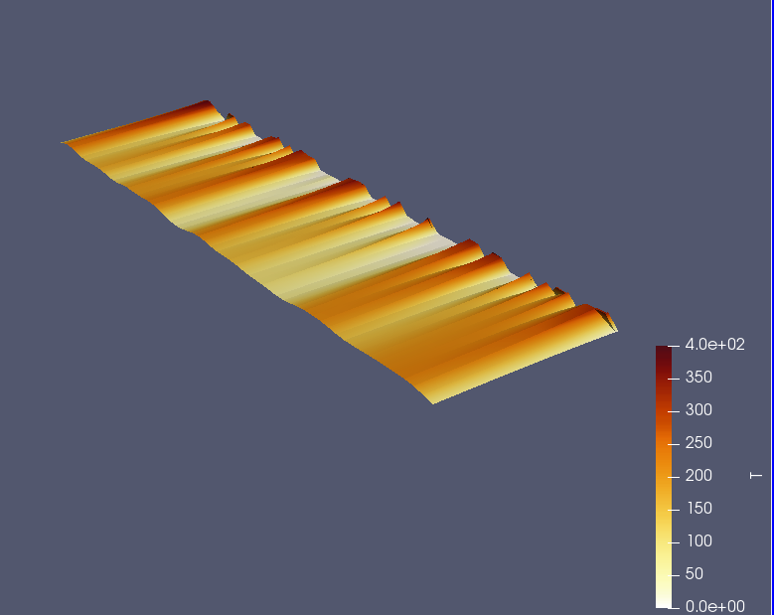

Showing how the sharp pulses slowly smooth out
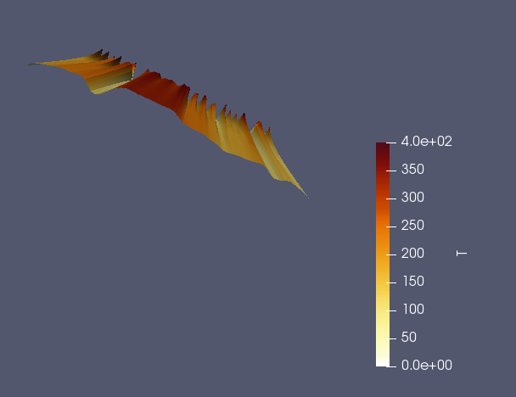

Showing the diffusion of heat. The plot was lengthened by increasing the time dimension cell size.

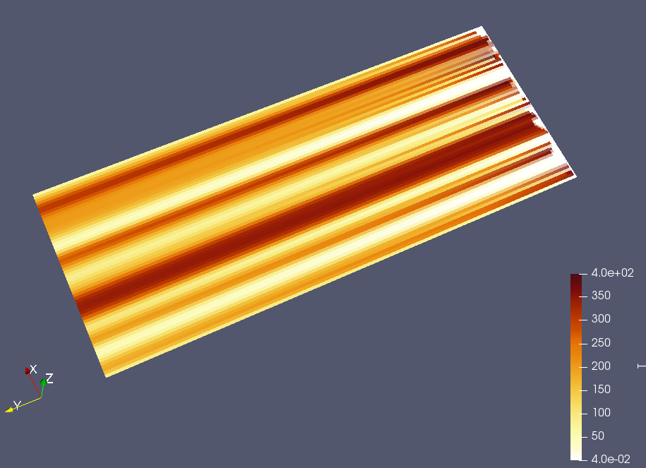

Isometric view

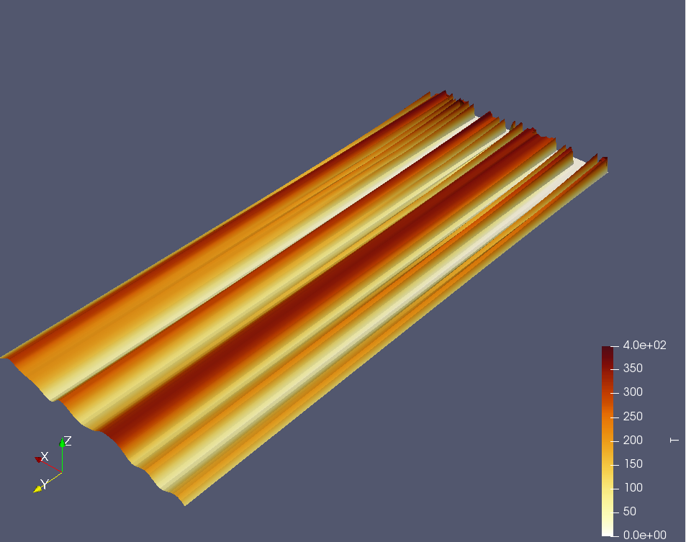

How the plot looks when spacing it out by 600 instead of 60:

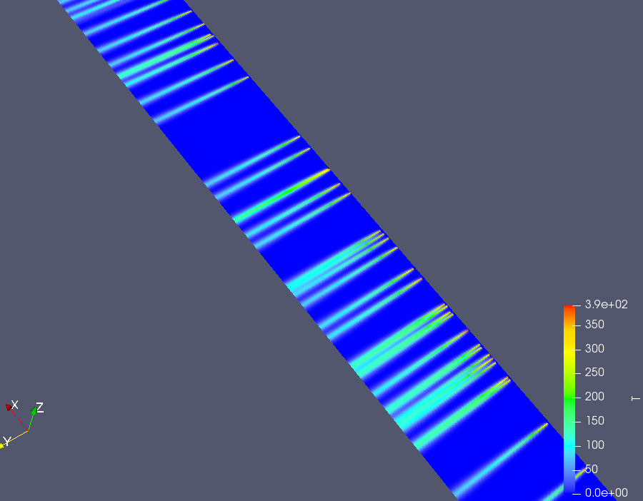

closeup view

